WEEK 1:
TASK 1:
SOLUTION:
int sum = 0;

while (input1 > 0) {
int digit = input1 % 10;

if (input2.equals("even") && digit % 2 == 0) {
sum += digit;
} else if (input2.equals("odd") && digit % 2 != 0) {
sum += digit;
}

input1 = input1 / 10;
}

return sum;
}
}

OUTPUT:
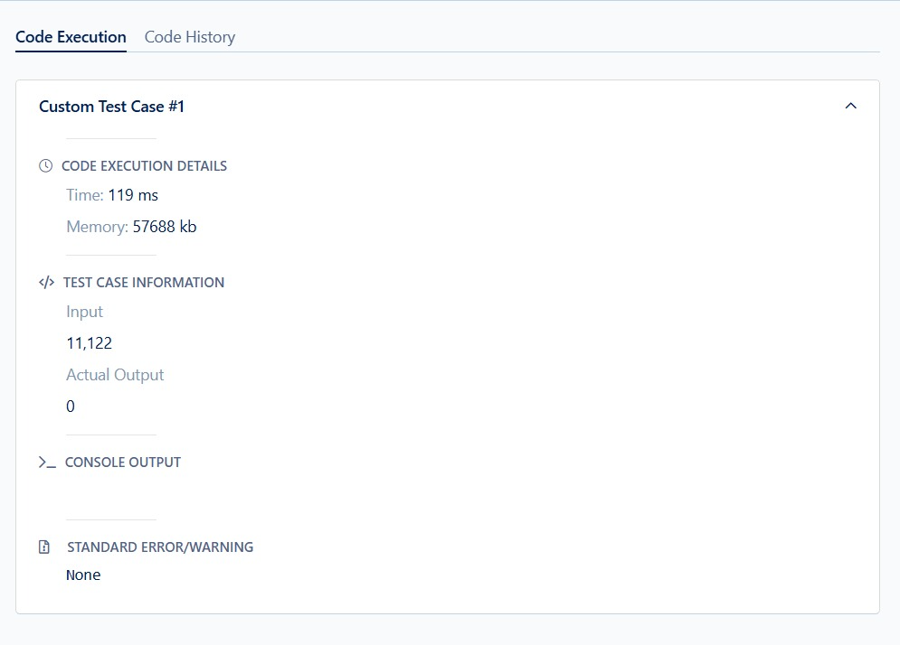
TASK 2:
SOLUTION:
import java.io.*;
import java.util.*;

interface PerformOperation {
boolean check(int a);
}

class MyMath {

public PerformOperation isOdd() {
return new PerformOperation() {
public boolean check(int a) {
return a % 2 != 0;
}
};
}

public PerformOperation isPrime() {
return new PerformOperation() {
public boolean check(int a) {
if (a <= 1) return false;
for (int i = 2; i <= Math.sqrt(a); i++) {
if (a % i == 0) return false;
}
return true;
}
};
}

public PerformOperation isPalindrome() {
return new PerformOperation() {
public boolean check(int a) {
int original = a, reversed = 0;
while (a != 0) {
int digit = a % 10;
reversed = reversed * 10 + digit;
a /= 10;
}
return original == reversed;
}
};
}

public boolean checker(PerformOperation p, int num) {
return p.check(num);
}
}

public class Solution {

public static void main(String[] args) throws Exception {

BufferedReader br = new BufferedReader(new InputStreamReader(System.in));
MyMath ob = new MyMath();

int T = Integer.parseInt(br.readLine());

while (T-- > 0) {
String[] input = br.readLine().split(" ");
int ch = Integer.parseInt(input[0]);
int num = Integer.parseInt(input[1]);

PerformOperation op;
boolean result;

if (ch == 1) {
op = ob.isOdd();
result = ob.checker(op, num);
System.out.println(result ? "ODD" : "EVEN");
} else if (ch == 2) {
op = ob.isPrime();
result = ob.checker(op, num);
System.out.println(result ? "PRIME" : "COMPOSITE");
} else if (ch == 3) {
op = ob.isPalindrome();
result = ob.checker(op, num);
System.out.println(result ? "PALINDROME" : "NOT PALINDROME");
}
}
}
}
OUTPUT:
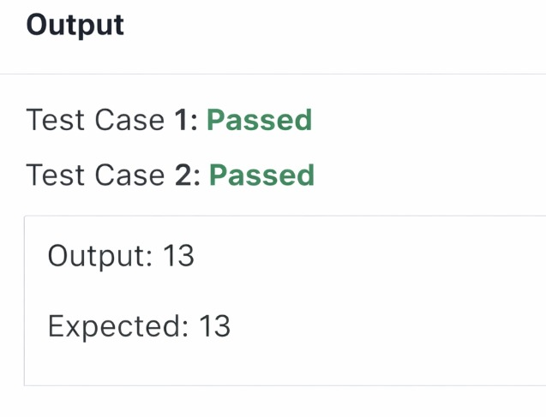

TASK 3:
SOLUTION:
import java.io.*;
import java.util.*;
// Read only region start
class UserMainCode
{
public int isPalinNum(int input1){
// Read only region end
int original = input1;
int reversed = 0;

while(input1 > 0) {
int digit = input1 % 10;
reversed = reversed * 10 + digit;
input1 = input1 / 10;
}
if(original == reversed) {
return 2; // Palindrome
} else {
return 1; // Not palindrome
}
}
}
OUTPUT:
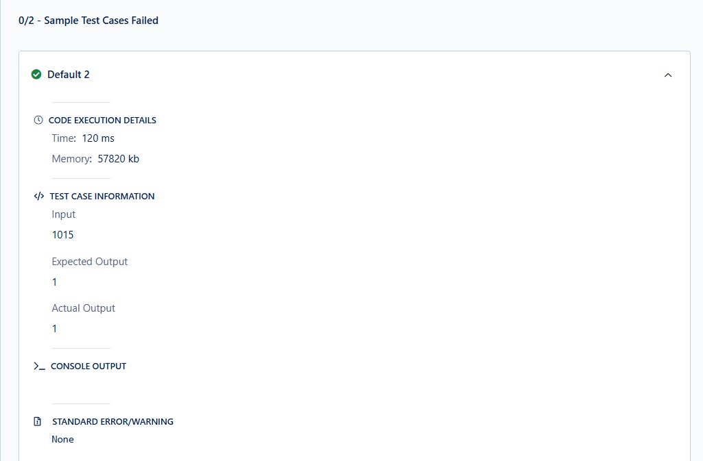

TASK 4:
SOLUTION:
public int isPalinNum(int input1){
// Read only region end
// Write code here...

int original = input1;
int reverse = 0;

while (input1 > 0) {
int digit = input1 % 10;
reverse = reverse * 10 + digit;
input1 = input1 / 10;
}
if (original == reverse) {
return 2;
} else {
return 1;
}
}

OUTPUT:
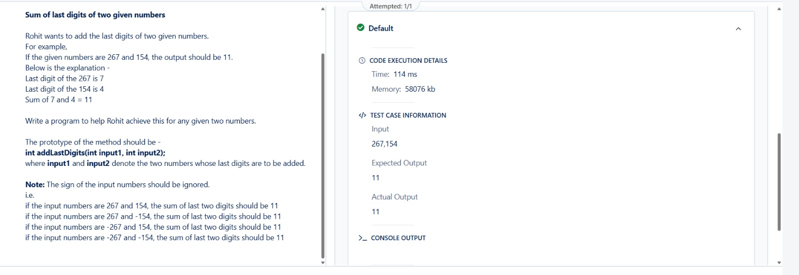

TASK 5:
SOLUTION:
int count = 0;

for (int num = input1; num <= input2; num++) {
if (num < 2) continue;

boolean isPrime = true;

for (int i = 2; i * i <= num; i++) {
if (num % i == 0) {
isPrime = false;
break;
}
}

if (isPrime) {
count++;
}
}
return count;

OUTPUT:
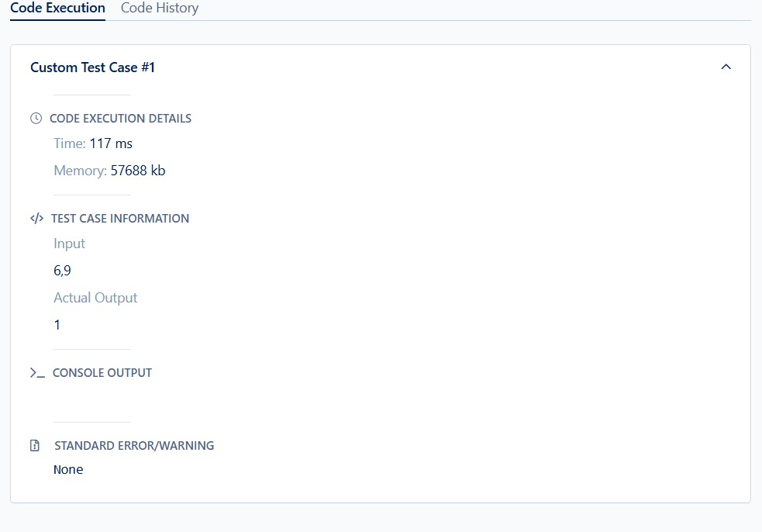

TASK 6:
SOLUTION:
int count = 0;

for (int num = input1; num <= input2; num++) {
if (num < 2) continue;

boolean isPrime = true;

for (int i = 2; i * i <= num; i++) {
if (num % i == 0) {
isPrime = false;
break;
}
}

if (isPrime) {
count++;
}
}
return count;

OUTPUT:
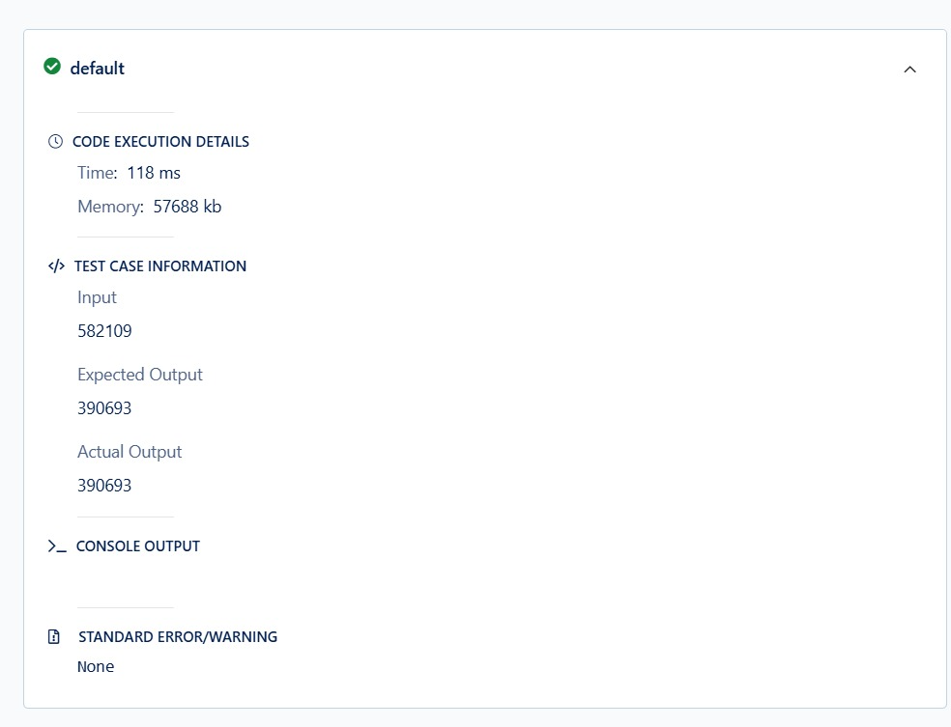

TASK 7:
SOLUTION:
HashSet<Integer> set = new HashSet<>();

while(input1 > 0){
int digit = input1 % 10;
set.add(digit);
input1 = input1 / 10;
}

return set.size();

OUTPUT:
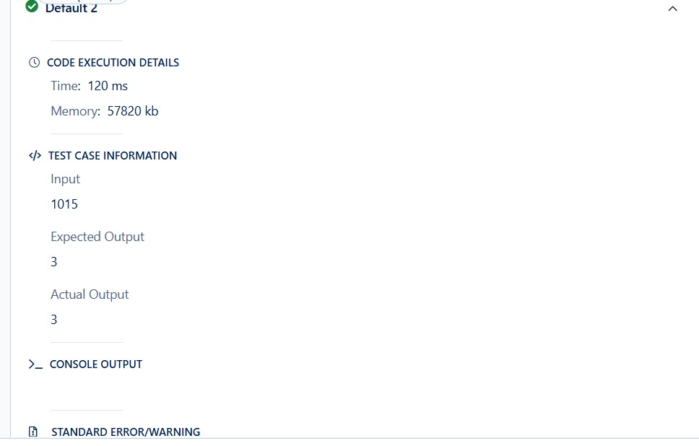

TASK 8:
SOLUTION:
int[] freq = new int[10];

for(int i = 0; i < input1.length; i++) {
int num = input1[i];

while(num > 0) {
int digit = num % 10;
freq[digit]++;
num = num / 10;
}
int maxFreq = 0;
int result = 0;
for(int i = 0; i < 10; i++) {
if(freq[i] > maxFreq || (freq[i] == maxFreq && i > result)) {
maxFreq = freq[i];
result = i;
}
}
return result;
}
OUTPUIT:
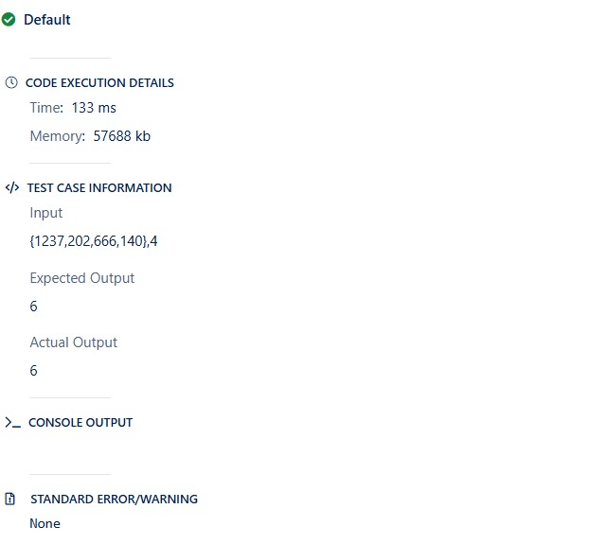
TASK 9:
SOLUTION:
public int sumOfNonPrimeIndexValues(int[] input1, int input2){
int sum = 0;
for (int i = 0; i < input2; i++) {
if (!isPrime(i)) {
sum += input1[i];
}
}
return sum;
}
private boolean isPrime(int n) {
if (n <= 1) return false;
for (int i = 2; i * i <= n; i++) {
if (n % i == 0)
return false;
}
return true;
}
OUTPUT:
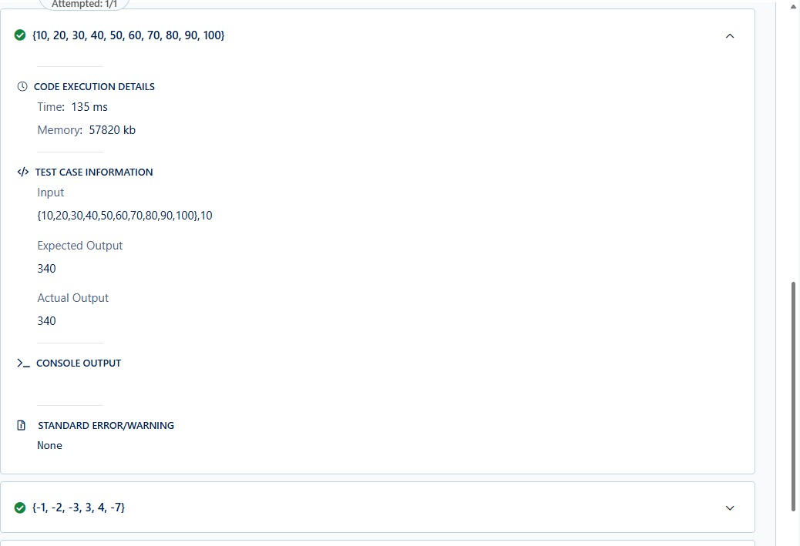

TASK 10:
SOLUTION:
public String secondWordUpperCase(String input1){
if (input1 == null || input1.trim().isEmpty()) {
return "LESS";
}

String[] words = input1.trim().split("\\s+");

if (words.length < 2) {
return "LESS";
}

return words[1].toUpperCase();
}

OUTPUT:
